**Inbound Shipment Invoice**

1. **Header Information**

|  |  |  |  |
| --- | --- | --- | --- |
| **Test ID** | TSR-SCH-Inbound Shipment Invoice | **Description** | Inbound Shipment Invoice |
| **Start Date** |  | **End Date** |  |
| **Categories** |  | | |
| **Preceding Test ID** |  | **Remarks** |  |

1. Test Execution and Result for Supplier Invoice Submission for one External reference against PO and Item.

| **Step #** | **Transaction System** | **Verify System** | **Test Step Instructions** | **Input Data** | **Expected Test Result** | **Actual Result with Reference Screenshot** | **Ok / Not Okay** | **Remark** | **Page. No** |
| --- | --- | --- | --- | --- | --- | --- | --- | --- | --- |
| 1 | SCH | SCH | Login to the SCH Portal | Enter the User ID and Password. | 1. Supplier Portal home page will be displayed. |  | Ok |  | 7 |
| 2 | SCH | SCH | To find the “INBOUND SHIPMENT INVOICE” menu | Scroll down on the left side panel to find “INBOUNDSHIPMENTINVOICE” Menu and click on it. | 1. The submenu will be displayed under the “INBOUNDSHIPMENTINVOICE” menu.   Submenus are “SUBMITINBOUND SHIPMENTINVOICE” and “INBOUND SHIPMENT INVOICE LIST”. |  | Ok |  | 9 |
| 3 | SCH | SCH | Navigate to INBOUNDSHIPMENTINVOICE screen | Click on the “SUBMITINBOUNDSHIPMENTINVOICE” sub menu to navigate to the Supplier Invoice submission initial screen.  In the initial screen Supplier needs to enter the External Reference Number. | 1. Supplier Invoice submission initial screen displayed. 2. Based on the External Reference Number, shipment details are displayed – Shipping Type, Service Agent, Transport Status, Main Supplier, Shipment Cost, SCH Invoice Status Supplier Invoice Number, SCH Reference Number Invoice Created By and Invoice Created On in the Inbound Shipment Invoice Details Table. |  | Ok |  | 11 |
|  | SCH | SCH | Enter valid External reference number | If the External reference number entered is not valid to the Supplier, then an error message will be displayed ‘Enter valid reference number’ | 1. External reference validated and then allowed to proceed next step. |  |  |  | 12 |
| 4 | SCH | SCH | Select the Shipment item to submit invoice. | Enter External Reference Number.  If the login Supplier is DB Schenker (20082) then the list of all the Suppliers involved in the Shipment cost will be shown in the list. DB Schenker needs to select any line item to submit invoice on behalf of other Supplier’s.  **Note:** Based on the SCH Invoice status, the checkbox needs to be enabled, if the invoice is already submitted then the checkbox cannot be enabled to submit invoice. In this case, change the External Reference Number. | 1. List of Service partners shown based on shipment cost. DBS can select any service partner to Submit invoice. 2. The screen navigates to main invoice creation screen. |  | Ok |  | 13 |
|  |  |  | Select the Shipment item to submit invoice. | Enter External Reference Number.  SCH should allow the supplier to submit invoice only if the login supplier is involved in the external reference number (this is based on Shipment number and Shipment cost configuration where the partners will be maintained)  **Note:** Based on the SCH Invoice status, the checkbox needs to be enabled, if the invoice is already submitted then the checkbox cannot be enabled to submit invoice. In this case, change the External Reference Number. | 1. The screen navigates to main invoice creation screen. |  |  |  | 15 |
| 5 | SCH | SCH | Verify the Invoice details in the Invoice details section.  Enter Shipper Name, Invoice Number, BL Number, Mode of Transport, Port of Loading, Port of Discharge and Remarks | Supplier can verify the entered reference number and remaining fields to be updated by the Supplier.  **Note:** Invoice Number must be the unique value, if the entered invoice number already exists apart from Reject / Draft / Pending Re-Submit status, then the system should not allow supplier to submit the invoice. | 1. Invoice details will be displayed based on the External Reference Number. 2. Invoice Number History is displayed with invoice Number & Status if the invoice number is duplicated for the Supplier. |  | Ok |  | 16 |
| 6 | SCH | SCH | Verify the Delivery details in the Delivery Details Table. | Next to Invoice History Section verify the delivery details of the entered shipment reference. | 1. Delivery data are displayed – PO Number, Item, Main Suppliers, Material, Material Description, Delivery Quantity, UOM, Delivery Charges (AED). |  | Ok |  | 18 |
| 7 | SCH | SCH | Verify the Shipment Cost in the Shipment Cost details section. | Shipment Cost details are based on the supplier & approved shipment cost configured in the SAP system. | 1. Shipment Cost details are displayed – Item, Category, Service agent, Net value, Currency, Description, Comments. |  | OK |  | 19 |
|  |  |  | Validate the Delivery Cost based on GRN and the Shipment Cost | Supplier will be allowed to submit invoice only when the delivery charges based on GRN, and the shipment cost matches the Supplier.  Partial invoice is not allowed | 1. Delivery charges and Shipment cost matched, and Supplier can submit the invoice |  |  |  | 20 |
| 8 | SCH | SCH | Attach Invoice Copy & Other Supporting Documents in the Attachments Section. | Attach the documents for Invoice Copy & Supporting Documents fields. | 1. In the Attachments section there is Invoice Copy & Supporting Documents to be attached. |  | OK |  | 19 |
| 9 | SCH | SCH | Comments Section | Supplier to give additional comments in the comments section. | 1. Comments can be given by the suppliers. |  | Ok |  | 19 |
| 10 | SCH | SCH | Supplier Bank Details | In the supplier Bank Details Section need to select the Bank A/C number, based on that A/C number the other details are displayed. | 1. Bank A/C Number needs to be selected, and it will display other data Bank Account Holder Name, Swift Code/ IFSC Code, Bank Name, Branch Address, Bank Country, Bank ID, IBAN. |  | Ok |  | 21 |
| 11 | SCH | SCH | Submit, Save as draft button | Submit and Save as Draft buttons will be shown on top and bottom of the page.  Optionally, Save as Draft can be used to draft the invoice and edit later and Submit | 1. Supplier can Submit the Invoice then the supplier can see the invoice in the List page. |  | OK |  | 21 |
| 13 | SCH | SCH | Navigate to INBOUND SHIPMENT INVOICE LIST  Screen | Submitted Invoices by the Supplier are listed in the List page. List page is a Report to view the previously submitted invoices and its status. | 1. Invoice Histories are displayed in the List page. |  | Ok |  | 22 |
| 14 | SCH | SCH | Detail Screen for specific SCH Reference Number. | Details of submitted invoice can be seen by clicking on the SCH Reference Number. | 1. Invoice details with respect to a particular SCH reference number is displayed along with the invoice approval status. |  | Ok |  | 24 |

1. Shipping & Logistics Team to review the Invoice and submit for approval.

| **Step #** | **Transaction System** | **Verify System** | **Test Step Instructions** | **Input Data** | **Expected Test Result** | **Actual Result with Reference Screenshot** | **Ok / Not Okay** | **Remark** | **Page. No** |
| --- | --- | --- | --- | --- | --- | --- | --- | --- | --- |
| 1 | SCH | SCH | Shipping & Logistics team will login the SCH portal and navigate to menu - REVIEW INBOUND SHIPMENT. | Scroll down on the left side panel to find “REVIEW INBOUND SHIPMENT” menu and click on it. | The submenu will be displayed under the “REVIEW INBOUND SHIPMENT” menu.   1. Submenus are “REVIEW INBOUND SHIPMENT INVOICE” and “LIST REVIEW INBOUND SHIPMENT INVOICE”. |  | Ok |  | 27 |
| 2 | SCH | SCH | Navigate to REVIEW INBOUND SHIPMENT INVOICE menu | By clicking on the Submenu “REVIEW INBOUND SHIPMENT INVOICE” the list of all Invoices submitted by the Suppliers will be displayed  ESA SL team needs to review and submit the invoices from the list | 1. Shows invoice list which needs to be reviewed and processed by the Shipping & Logistics team. |  | Ok |  | 27 |
| 3 | SCH | SCH | Navigate to the review and update Page of the invoice | While clicking on the SCH Reference Number in the list page, it will navigate to the review and update page of the invoice. | 1. SL Team needs to verify the Invoice then enter the S&L Comments, Payment Terms section fields, Tax Code and then Submit |  | Ok |  | 28 |
| 4 | SCH | SCH | Submit, Correct, Reject & Save As Draft | Correct, Submit, Reject and Save as Draft buttons will be shown on top and end of the page. | 1. The Invoice is processed by the shipping and click submit for next approval or Reject the Invoice completely and stop further processing or Correct the invoice then the invoice goes to Supplier again for correction and Supplier can resubmit and one more option to Save as draft the Invoice and to modify later. |  | Ok |  | 32 |
| 6 | SCH | SCH | List page of the Shipping Team | Once the SL Team processed the invoice it will be moved to List page. | 1. The Invoice details will be moved to the List Page of SL Team with the status called ‘Pending Approval’ by navigating to the LIST REVIEW INBOUND SHIPMENT INVOICE menu. |  | Ok |  | 30 |
| 7 | SCH | SCH | Track Invoice Status | Will be shown, while clicking on the workflow icon on the message column of that Invoice | 1. In the Invoice List and Details page the status and log of approval will be displayed. |  | Ok |  | 31 |
| 8 | SCH | SCH | Final Approver | The status will be changed as Approved  and logistics Invoice will be parked in SAP. | 1. SAP Invoice Status and SAP Invoice Number will be shown in SCH List page for the SL Team and the Supplier list page.   The invoice attachments are moved to SAP invoice as well. |  | Ok |  | 39 |
| 9 | SCH | SCH | Invoice Details are parked in the SAP system, then the Status will change as “Under Accounts Review” in the SCH Portal. | When the Invoice gets posted from SCH to SAP, Invoice Status get generated. | 1. From the SCH side, the Invoice Status will be shown in the Invoice List Page and in the Details Page both the Invoice Status will be shown in the Invoice Details section. |  | Ok |  | 43 |
| 10 | SCH | SCH | Invoice Status – “Accepted by Finance” | The SAP invoice status will change after the Invoice gets posted from SAP by the Finance team. | 1. From the SCH side, the Invoice Status will be changed as “Accepted by Finance”, will be shown in the Invoice List Page and in the Details Page. |  | Ok |  |  |

**Step 1:**

1. Login to the SCH Portal by giving the respective User ID & password.

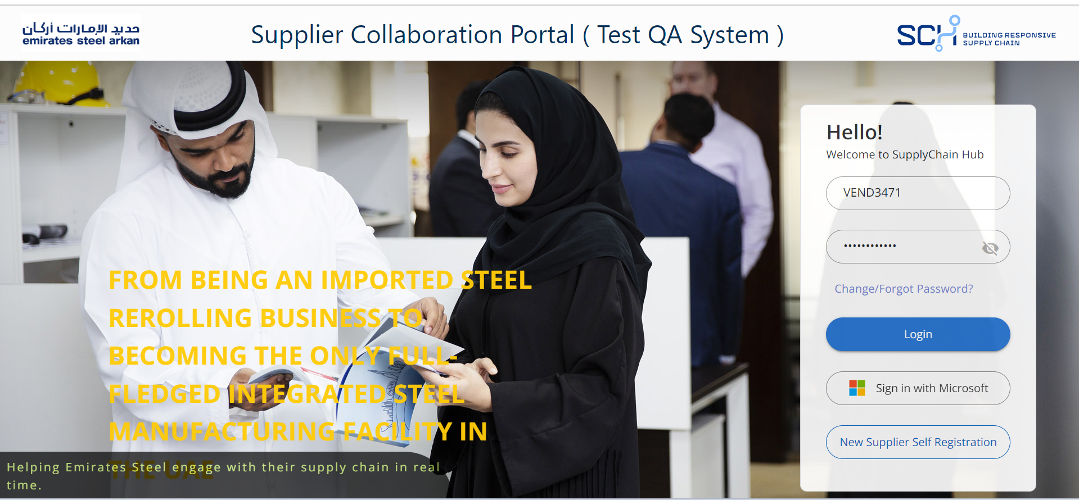

B): Navigates to home screen after login.

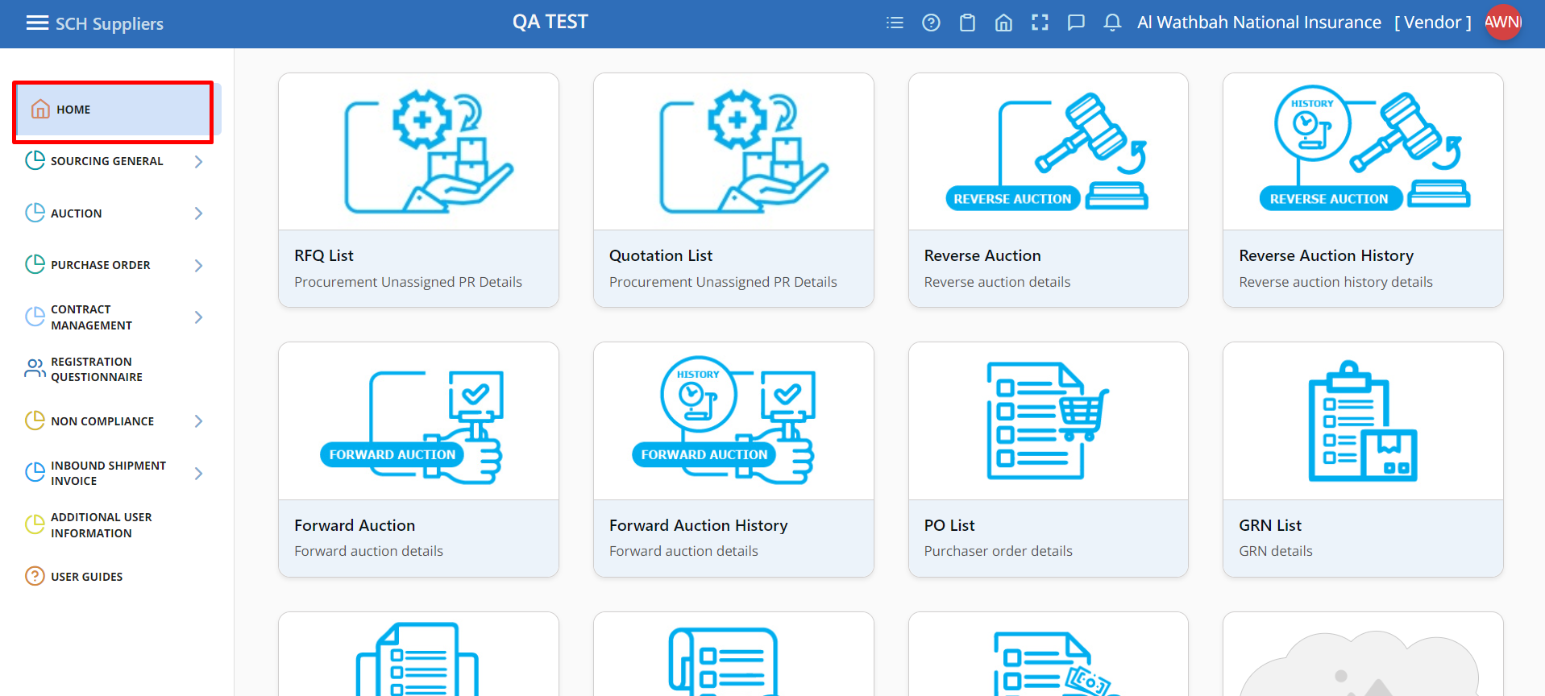

**Step 2**:

**A):** In the home screen there will be “INBOUND SHIPMENT INVOICE” menu on the left-hand side of the screen.

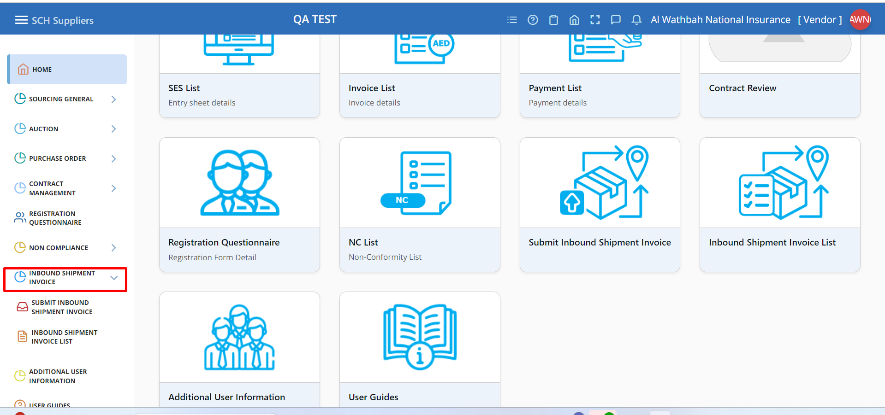

**B):** Click on the “INBOUND SHIPMENT INVOICE” menu, submenus will be displayed. They are   
 1. SUBMIT INBOUND SHIPMENT INVOICE  
 2. INBOUND SHIPMENT INVOICE LIST

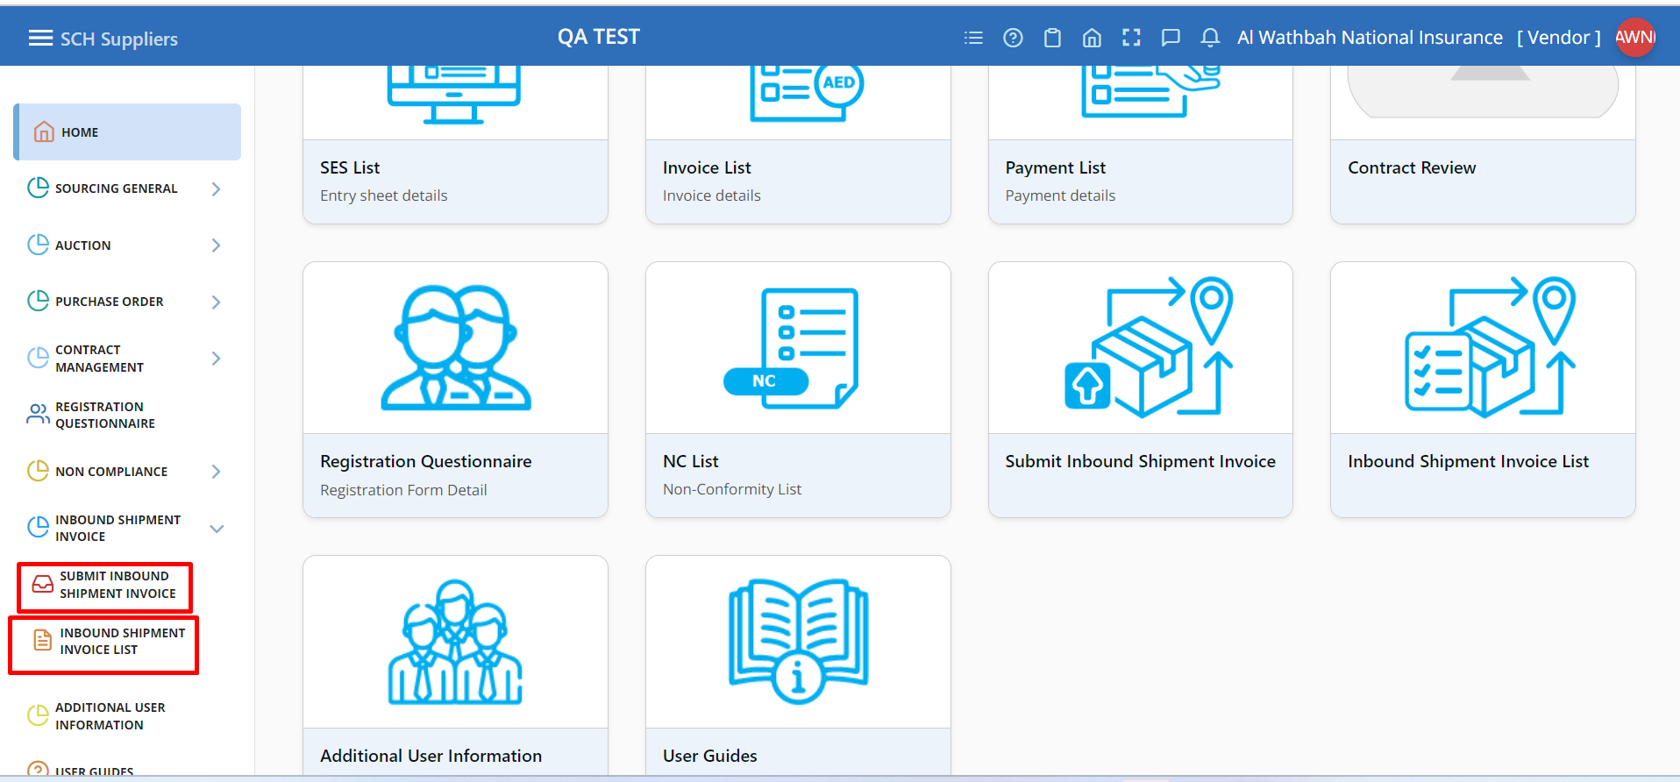

**Step 3:**

**A):** Click on the “SUBMIT INBOUND SHIPMENT INVOICE” sub menu.

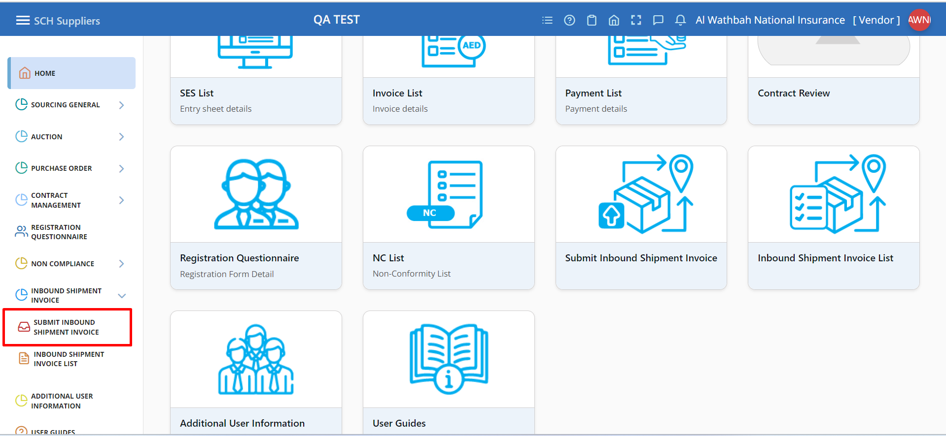

**A):** Click on the “SUBMIT INBOUND SHIPMENT INVOICE” sub menu.

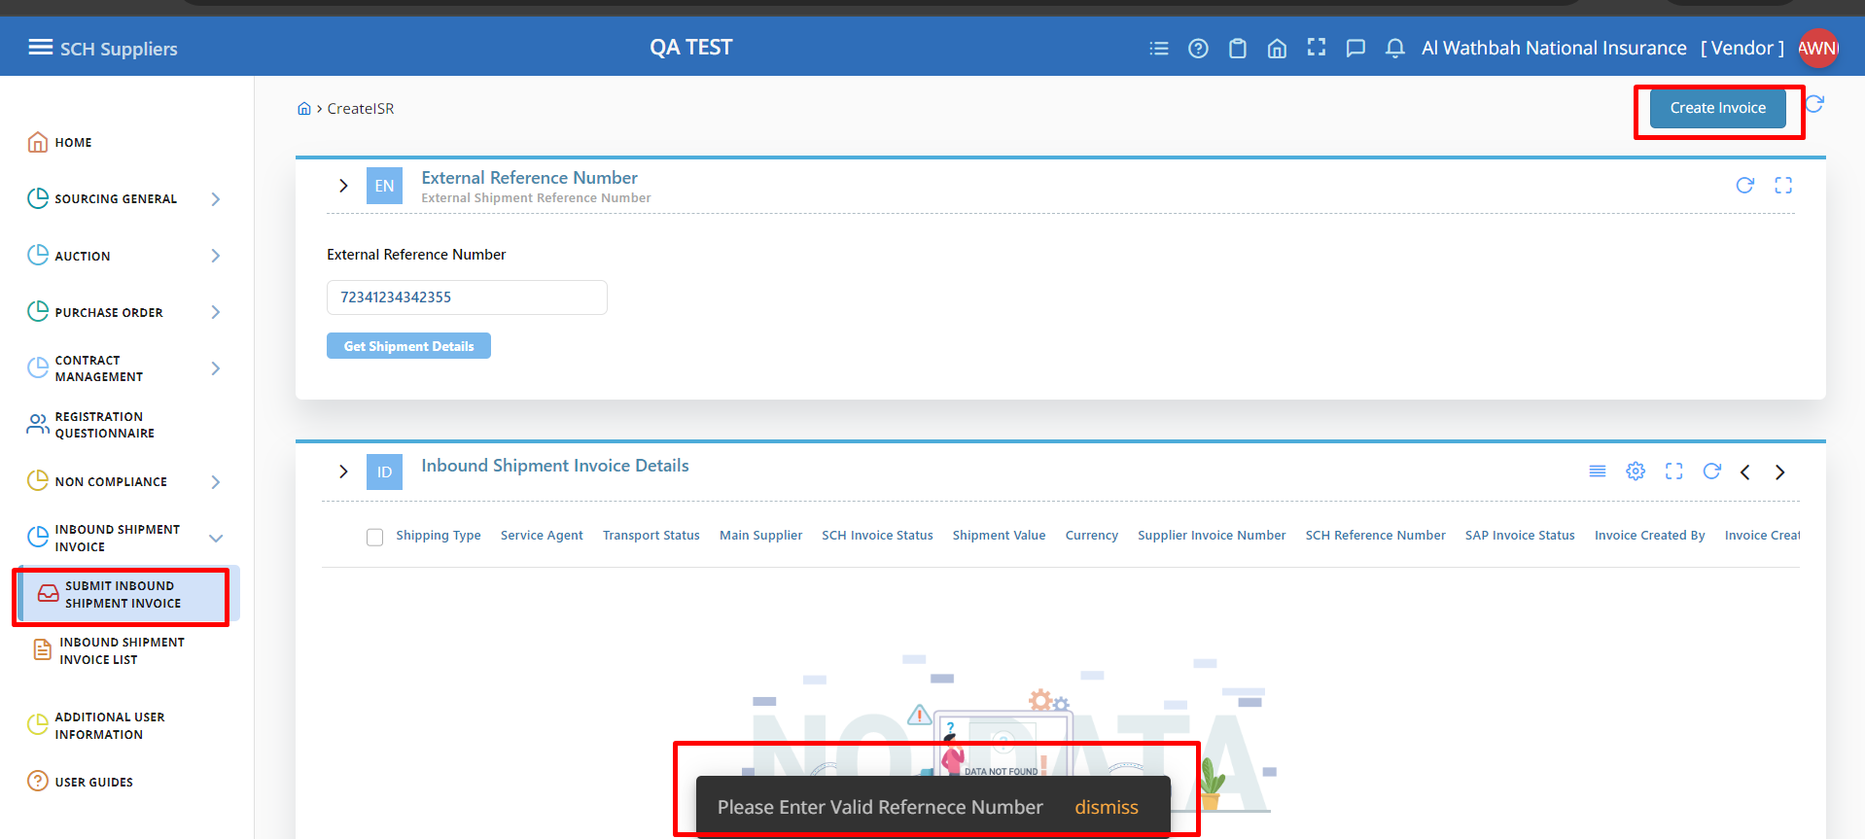

**Step 4:  
A)** After clicking on the SUBMIT INBOUND SHIPMENT INVOICE menu, the screen navigates to the Supplier Initial screen.

In the Supplier initial screen, Supplier needs to enter the External Reference Number then it will show the Invoice details below. If the SCH Invoice Status as Invoice Submitted, Draft, Pending Approval, Pending Resubmit, Approved, then the check box will be disabled. This means the Invoice is already in process for the entered external reference number based on status. In this case, Supplier can enter another external reference number for which the invoice is not yet submitted.  
  
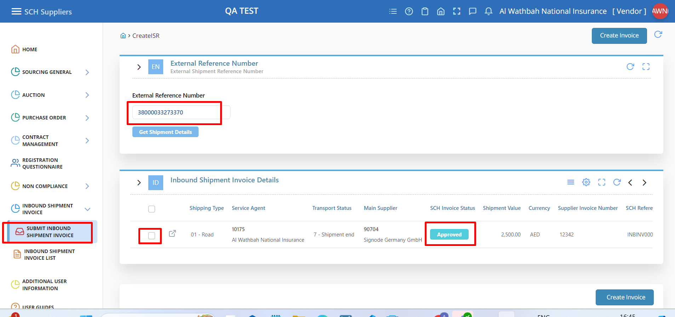

B) After clicking on the SUBMIT INBOUND SHIPMENT INVOICE menu, the screen navigates to the Supplier Initial screen. In the DB Schenker initial screen, DB Schenker needs to enter the External Reference Number then it will show the Invoice details below.

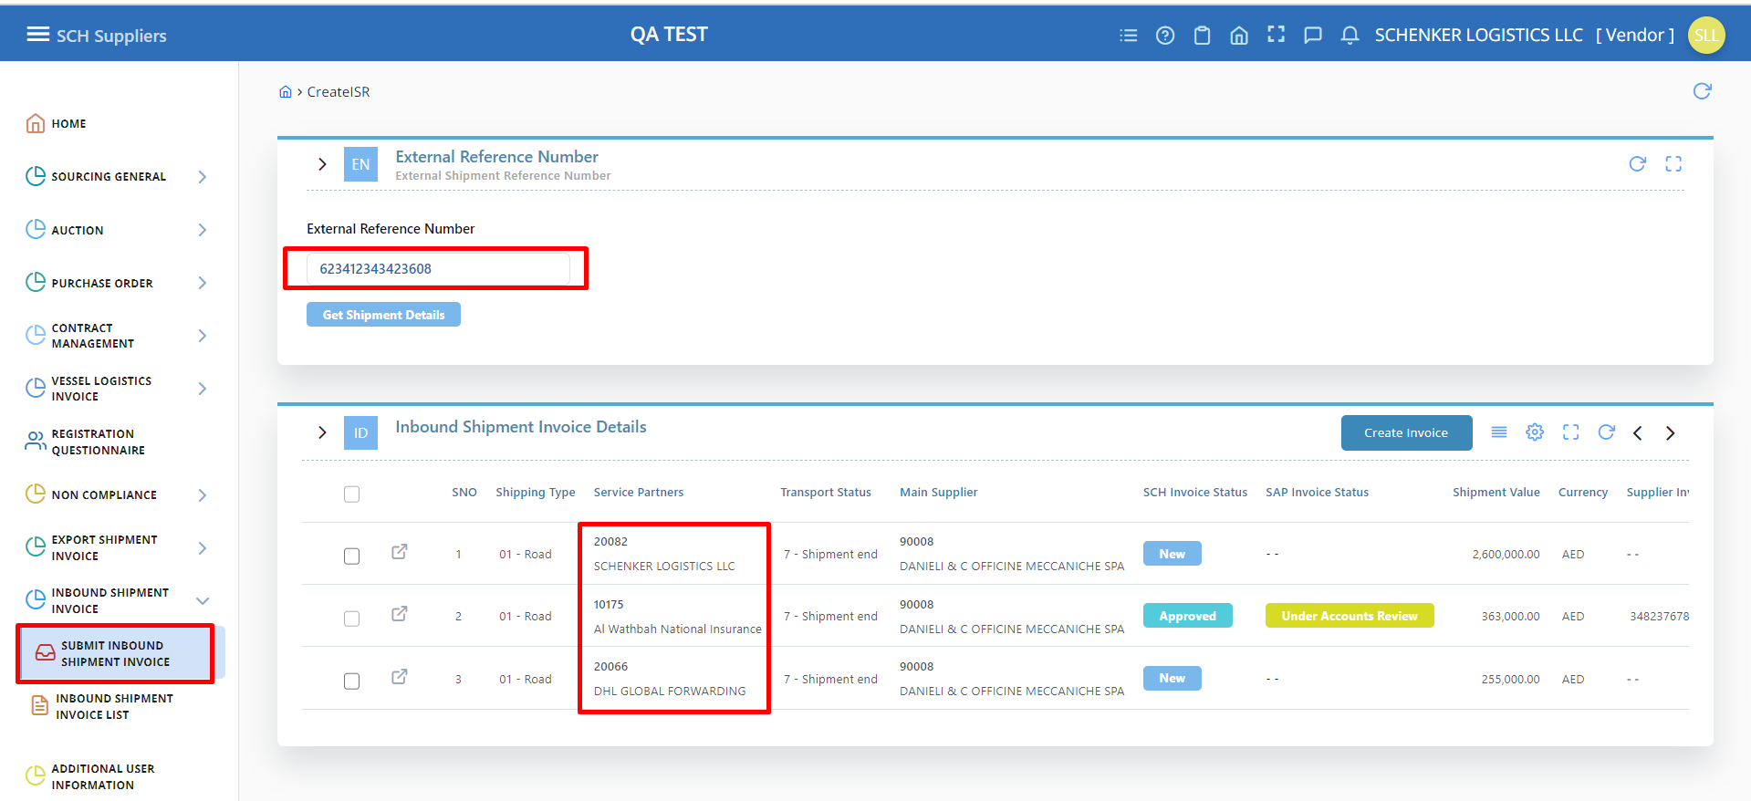

1. In the Supplier Initial screen, Supplier needs enter the External Reference Number.

Based on the External Reference Number the Inbound Shipment Invoice Details will be shown, Then Click on the create Invoice Button in the page header.

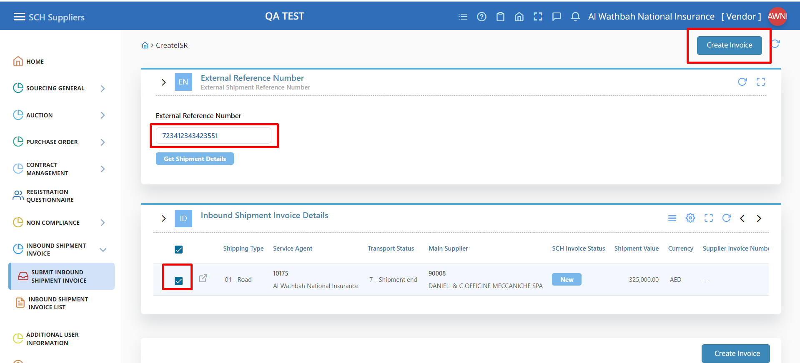

**Step 5:**   
 **A)** For the same External Reference Number with same Invoice Number with except Rejected or Unique Value system didn’t allow to submit. It will be through error.  
  
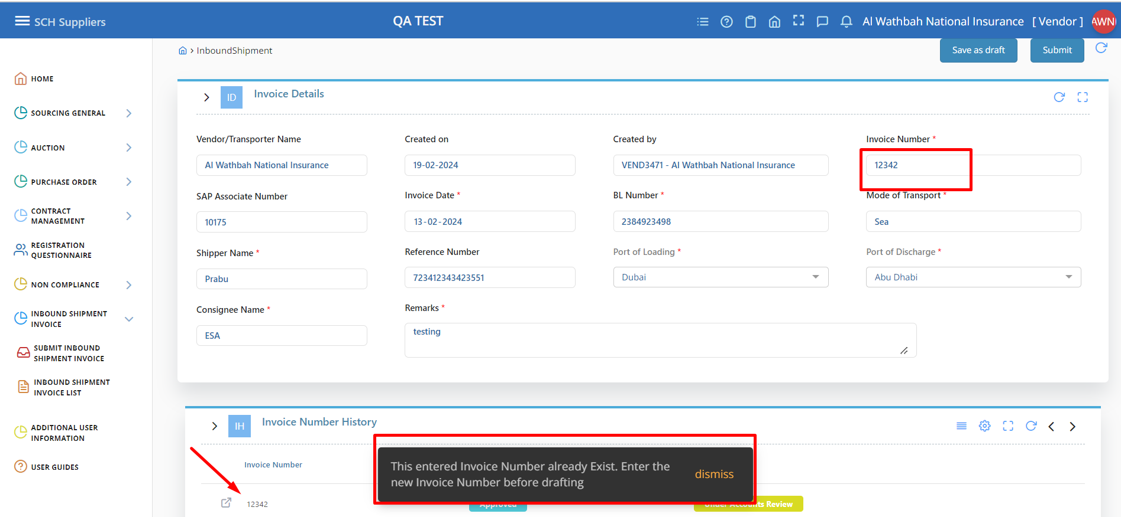

**B):** Same Invoice Number with Rejected Status then the system will allow to submit the invoice.

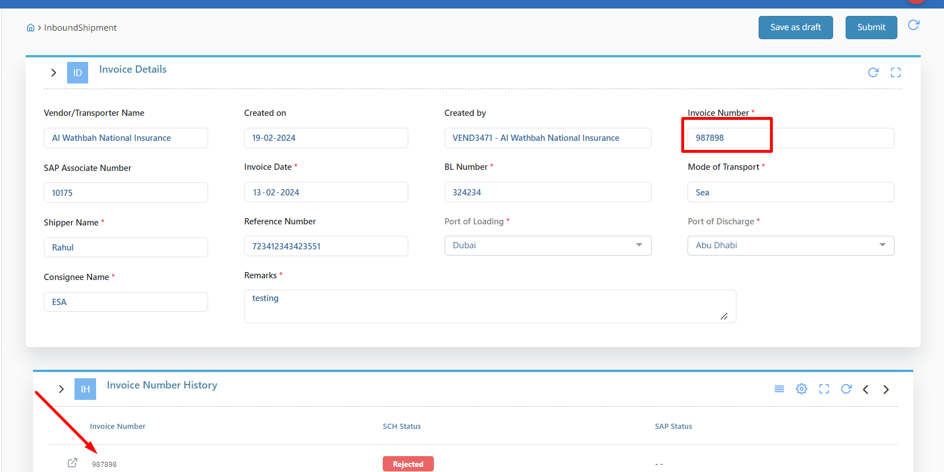

**Step 6:**   
  
**A)** Delivery Details table based on the External Reference Number and Supplier.  
  
  
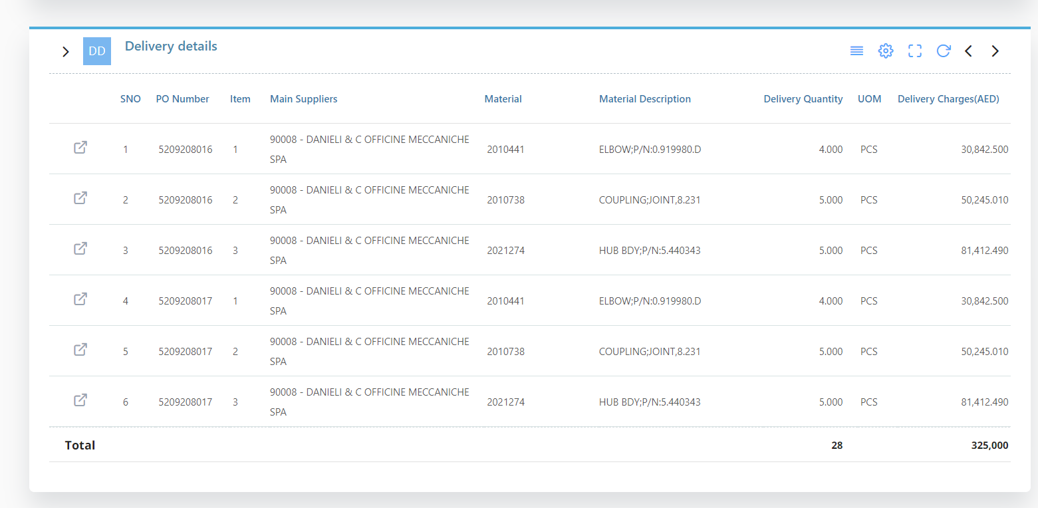

**Step 7:**   
Attachments, Shipment Cost Details and Comments are given by the Supplier.

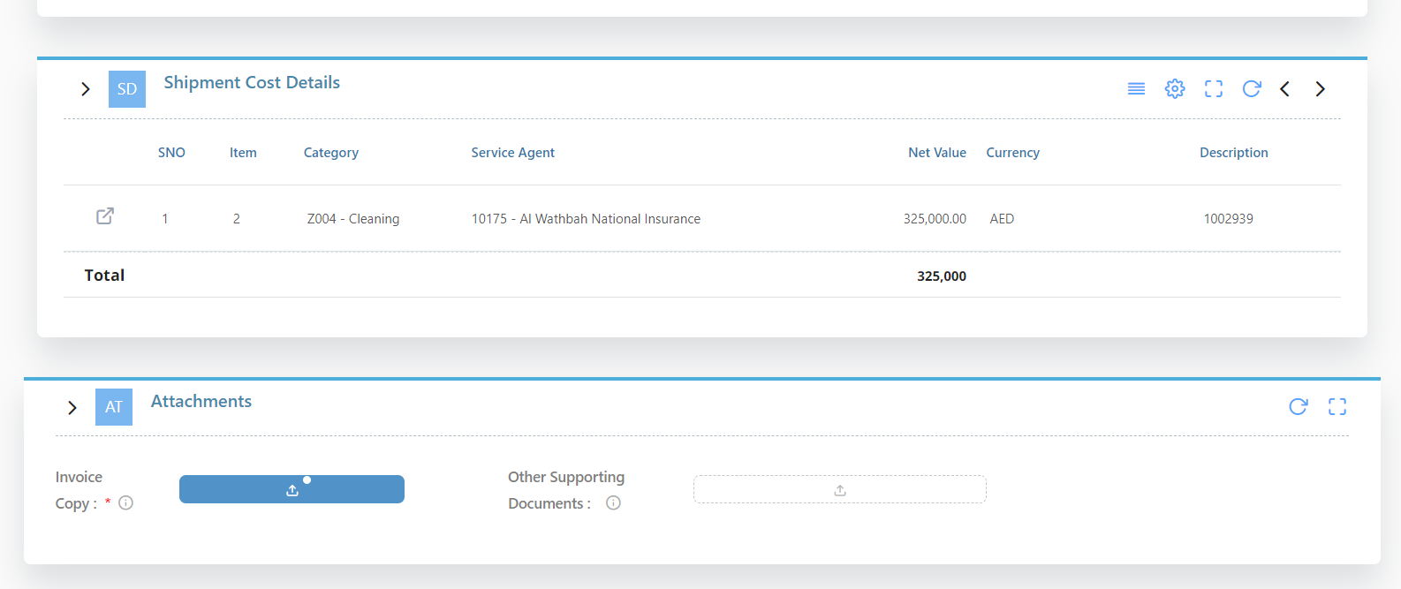

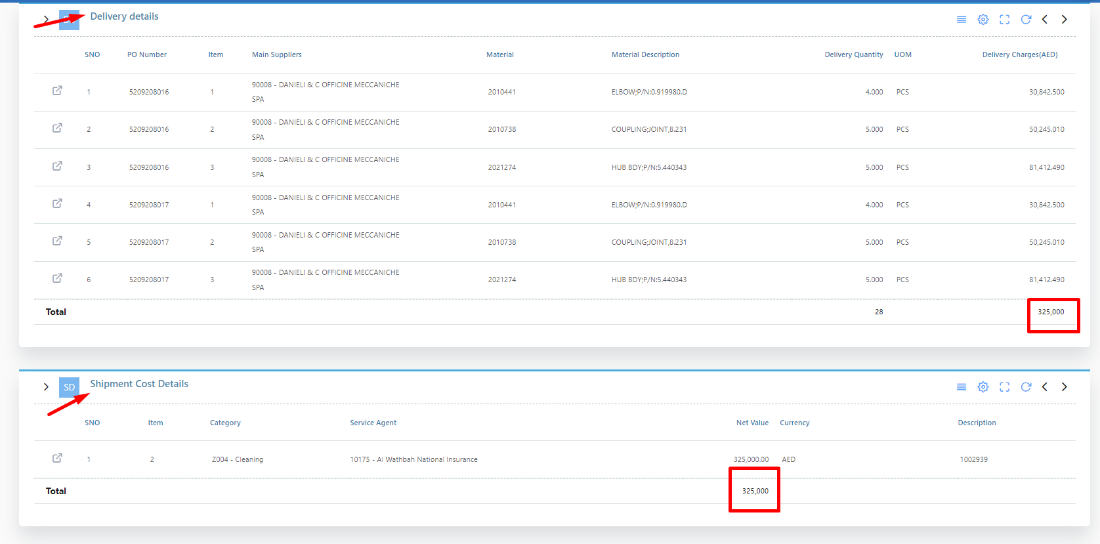

**Step 10:**

**A)** In the Supplier Bank Details, Supplier needs to select Bank A/C Number, based on that A/C Number the other details are displayed. Then click on the Submit Button which is on the top and bottom of the page. Once the Invoice submitted by the supplier it will goes for the approval.  
  
  
  
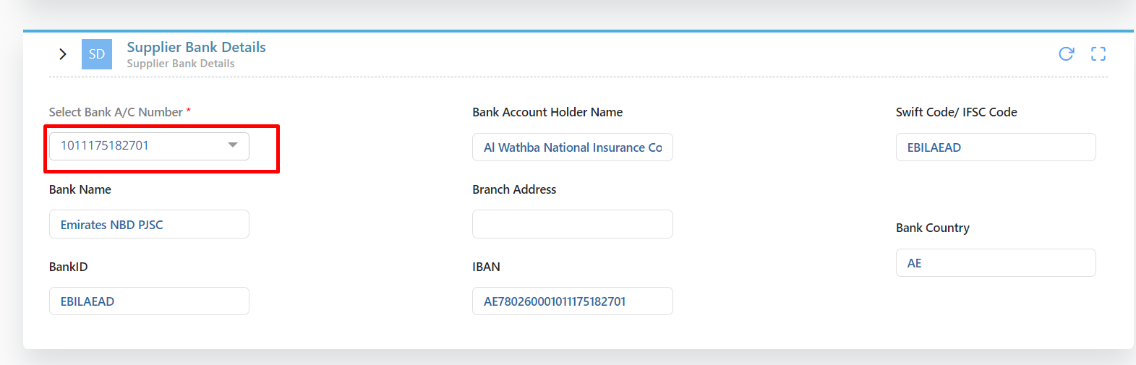

**Step 13:**  
**A)** Once the Invoice is submitted by the Supplier it will be the history, then it will display in the list page.  
  
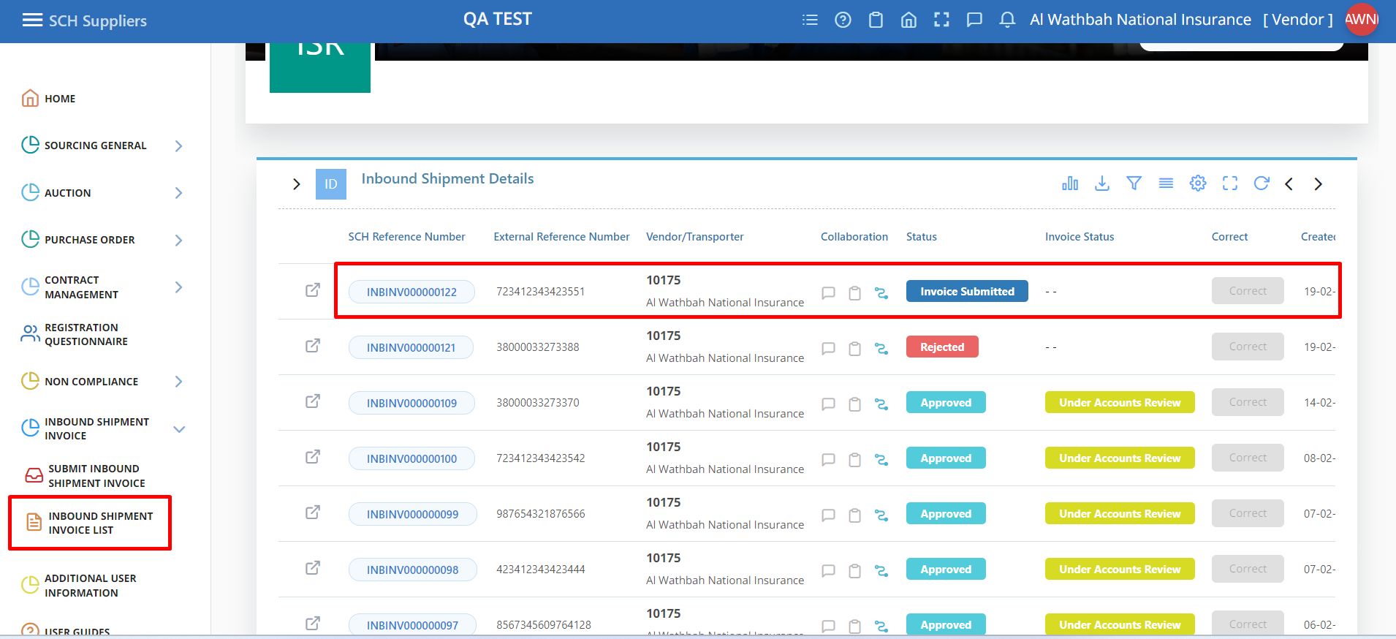

**B):**  
Supplier can track approvers while click on the blue icon which is in the Collaboration column

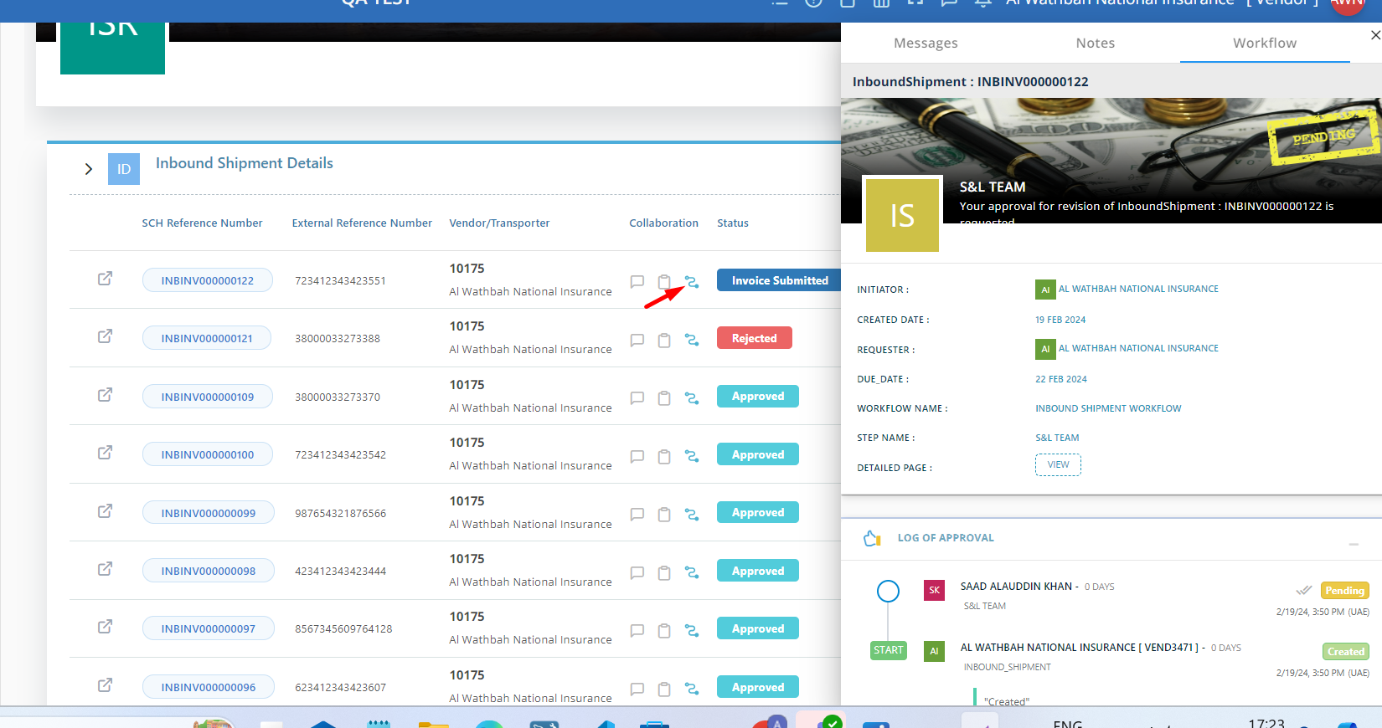

**Step 14:**  
**A)** In the list page while click on the SCH Reference Number will display all the details which is submitted by the supplier.

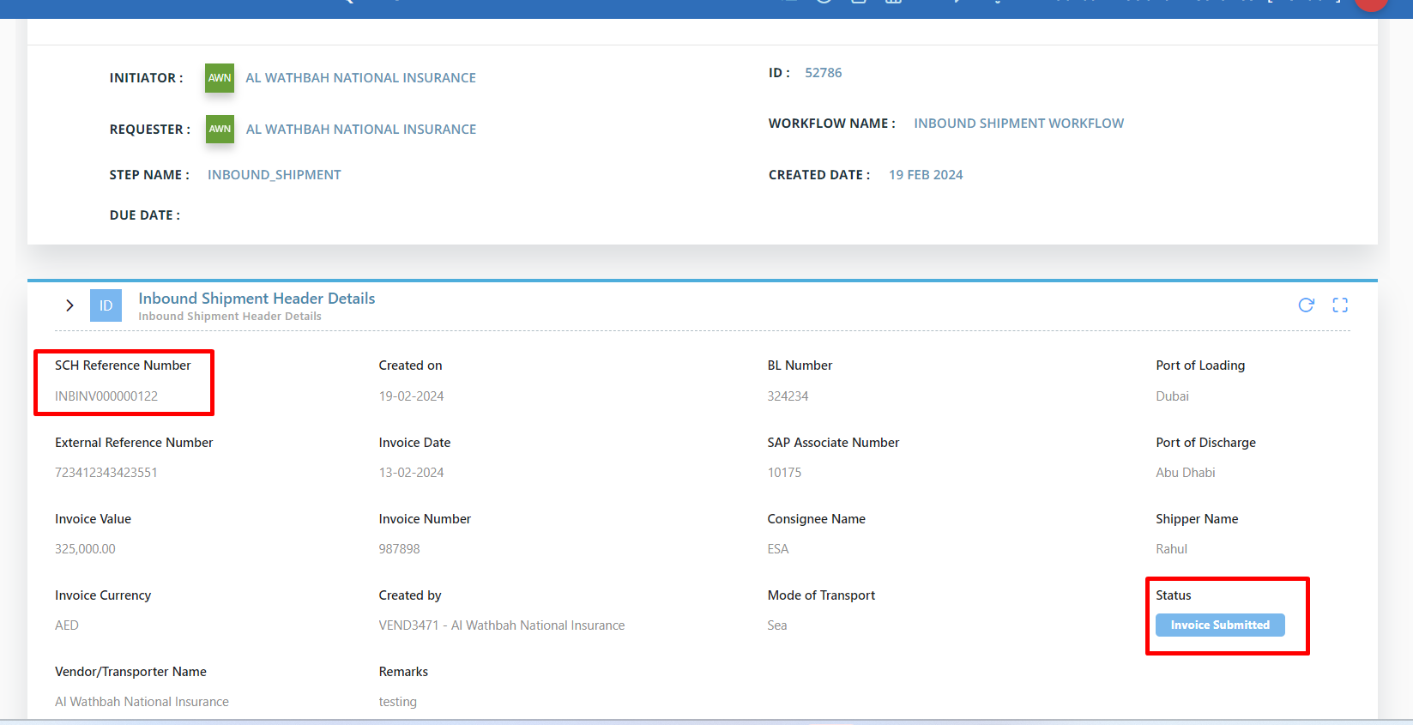

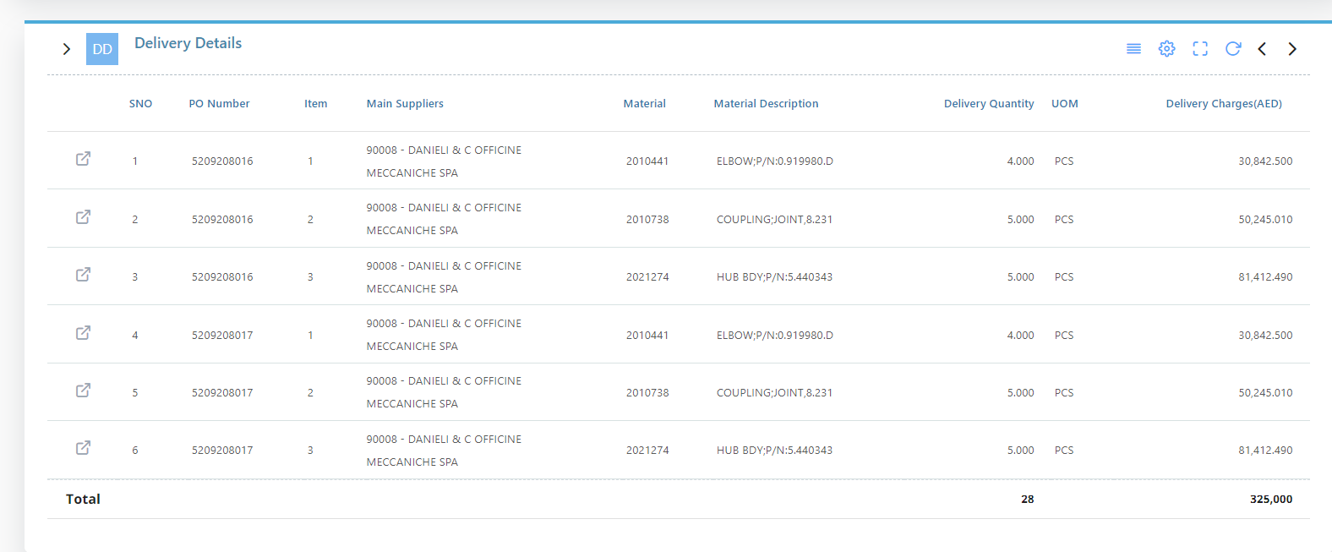

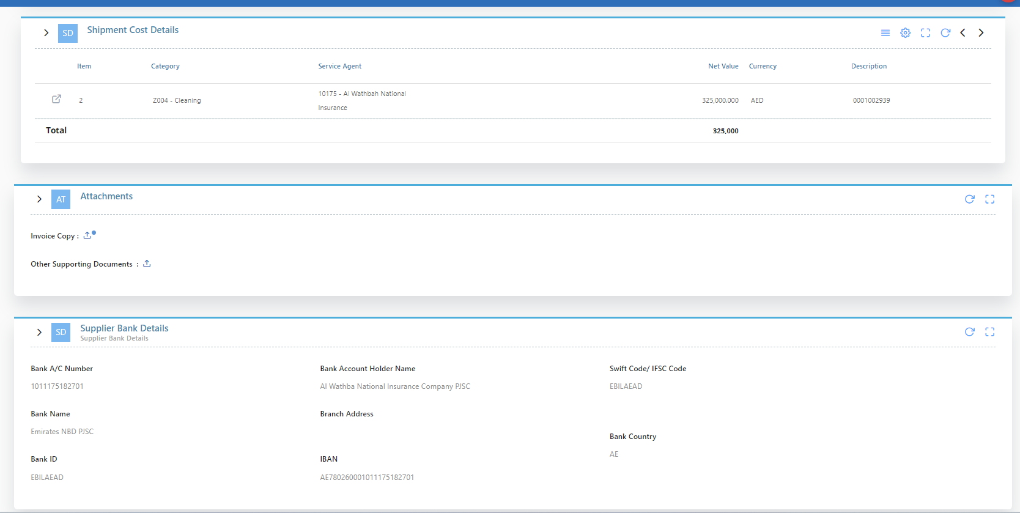

**Shipping Team Screens**

**Step 1:**  
**A)** In the Shipping Team invoice list shows which are needed to review and approve by the Shipping Team.  
  
  
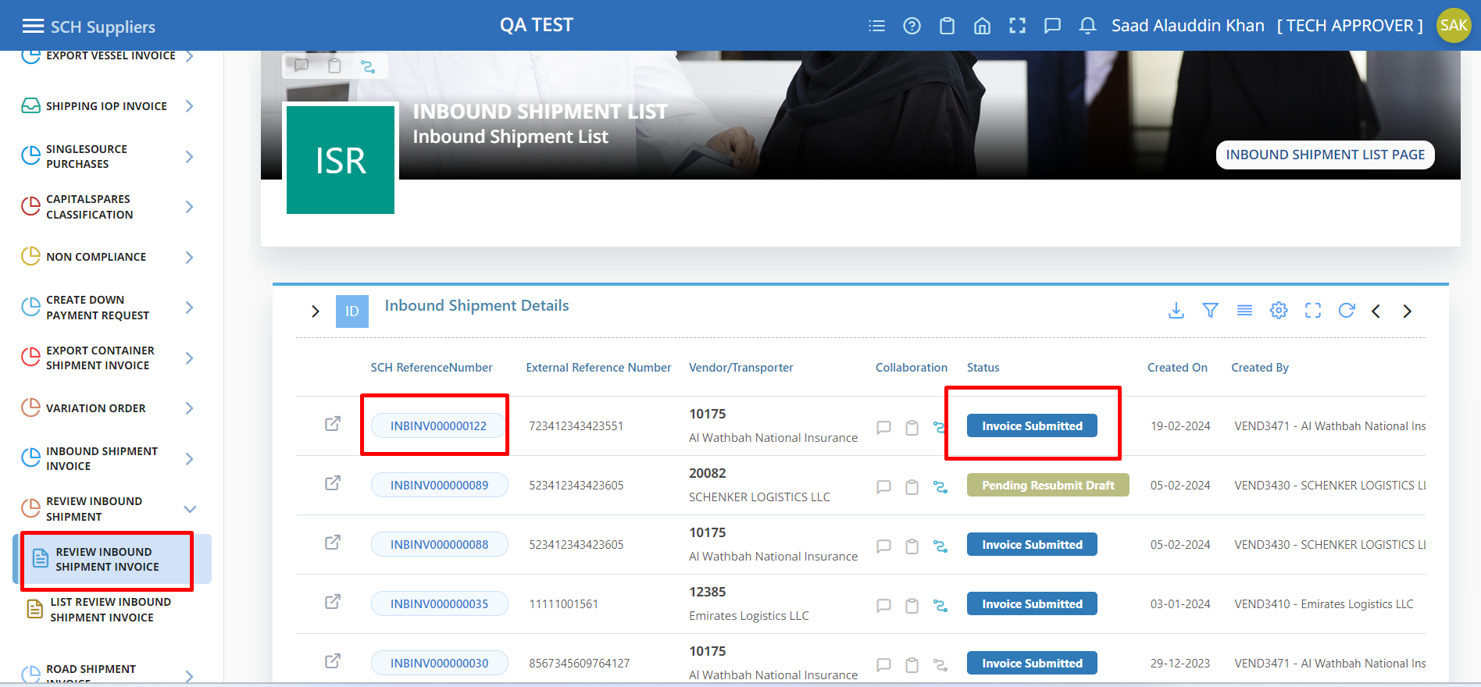

**Step 3:**  
 **A) While** Clicking on the SCH Reference Number it navigates into the Shipping team Update page, in that page supplier entered details are displayed then shipping team needs to enter the data in the S&L Comments & Payment Terms section.

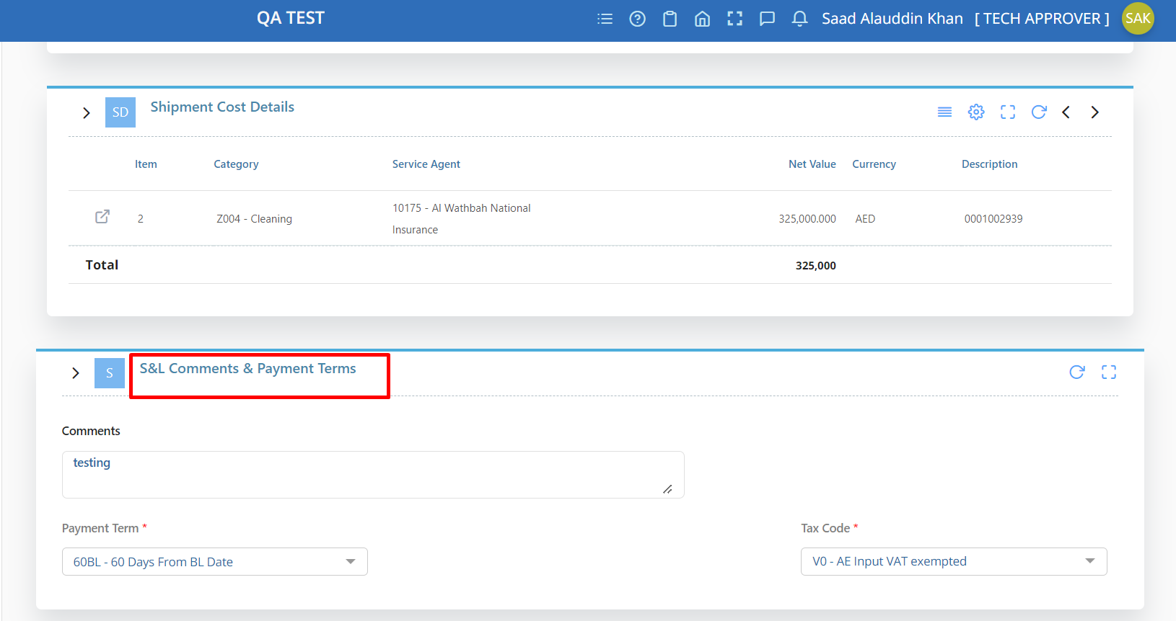

On that Submit popup, Next Approver and Remarks (Not mandatory) field will be shown. Then click on the “OK” button.

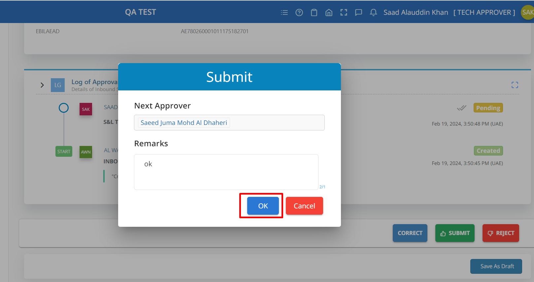

Once the Invoice Updated by the Shipping Team, the invoice will move to List page of Shipping team with the status Pending Approval by click on the submenu LIST REVIEW INBOUND SHIPMENT INVOICE.  
  
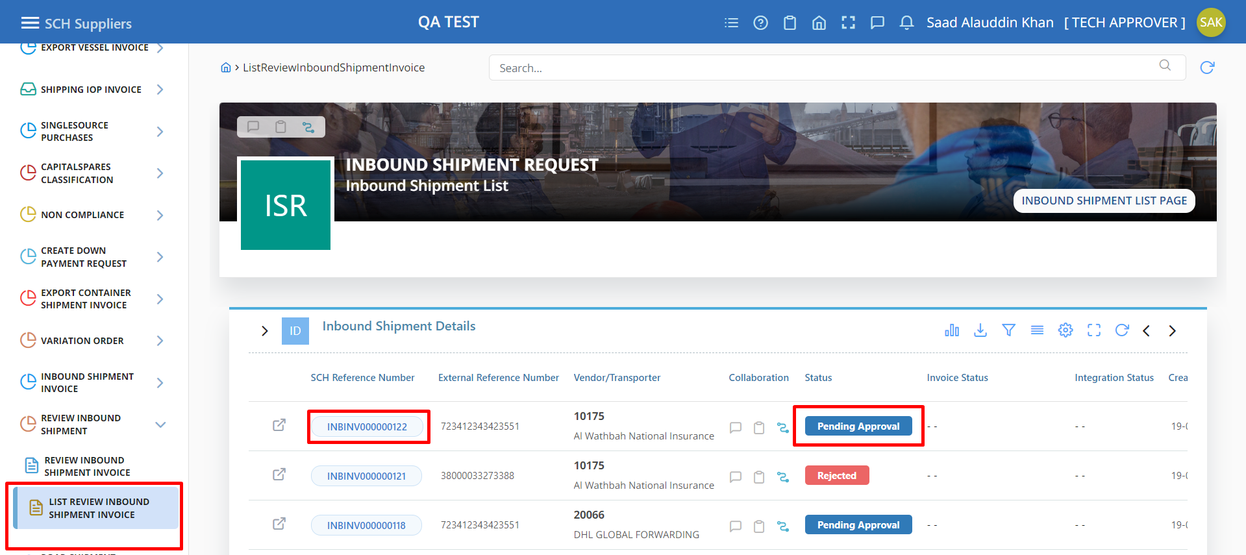

After all the Approvers approve the Invoice, the status will be changed as “Approved” and the Invoice details will be moved to SAP.   
  
  
  
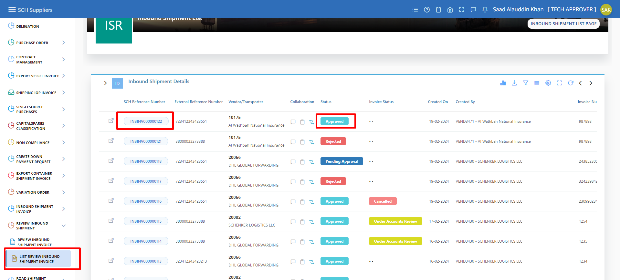

**Step 4:  
A)**

In the Bottom & Top of the page have action Button, once click on the Correct Button the Correct popup with Remarks (Not mandatory) field will be shown. Then click on the “OK” button.

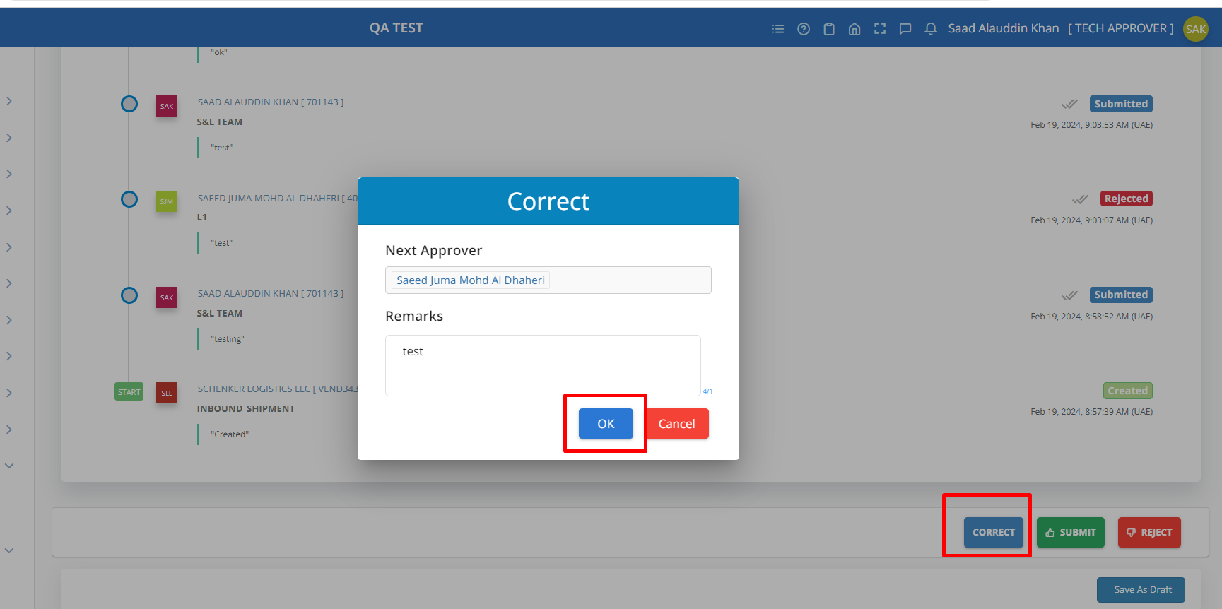

**Step 6:  
 A)** Once the Invoice Updated by the Shipping Team, the invoice will move to List page of Shipping team with the status Pending Re-Submit, then the Invoice again goes to Supplier for Review again by click on the submenu LIST REVIEW INBOUND SHIPMENT INVOICE.

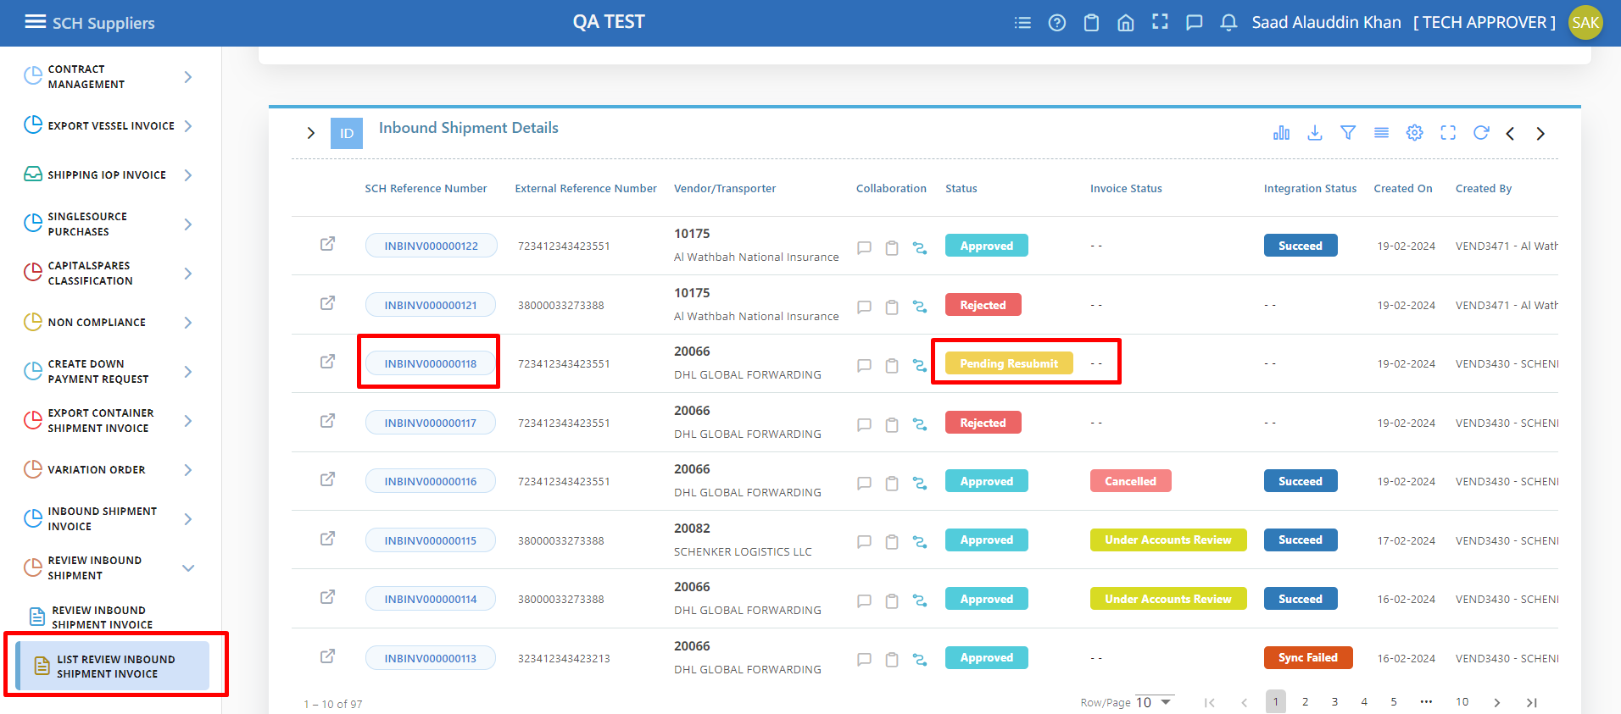

1. In the Supplier List page, the correct Invoice will display with the status Pending Resubmit and Correct button will enable to modify the Invoice or Click on the SCH Reference Number it navigate to Details page.

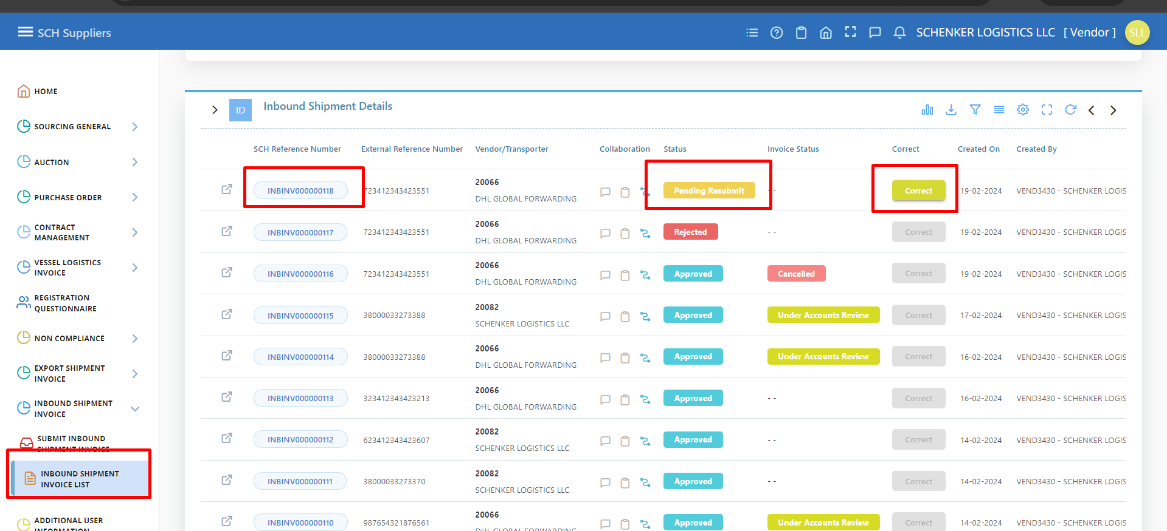

1. In the Details Page for Pending Resubmit status Modify Button will enable to update the Invoice again by supplier.

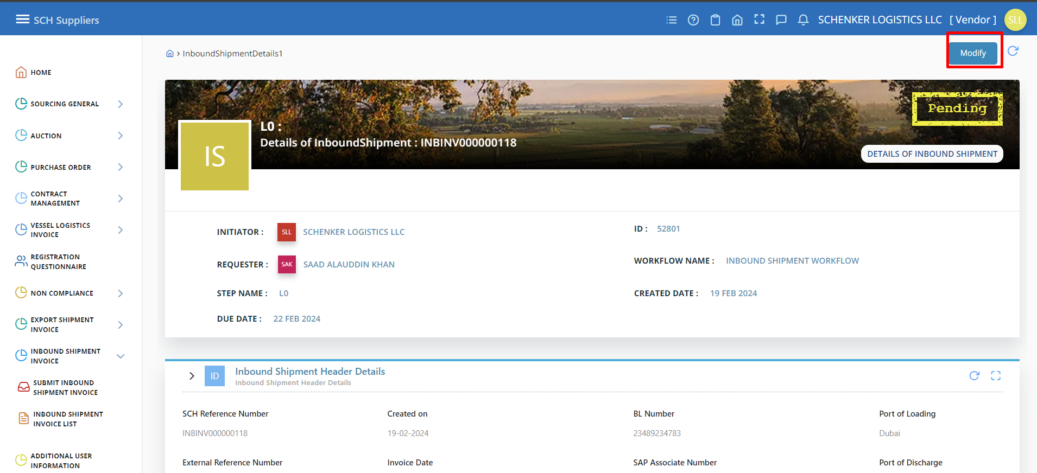

1. It will navigate to the Update page of the supplier, in that page supplier has option to modify and submit the invoice or save it as Draft to Process the invoice Later.

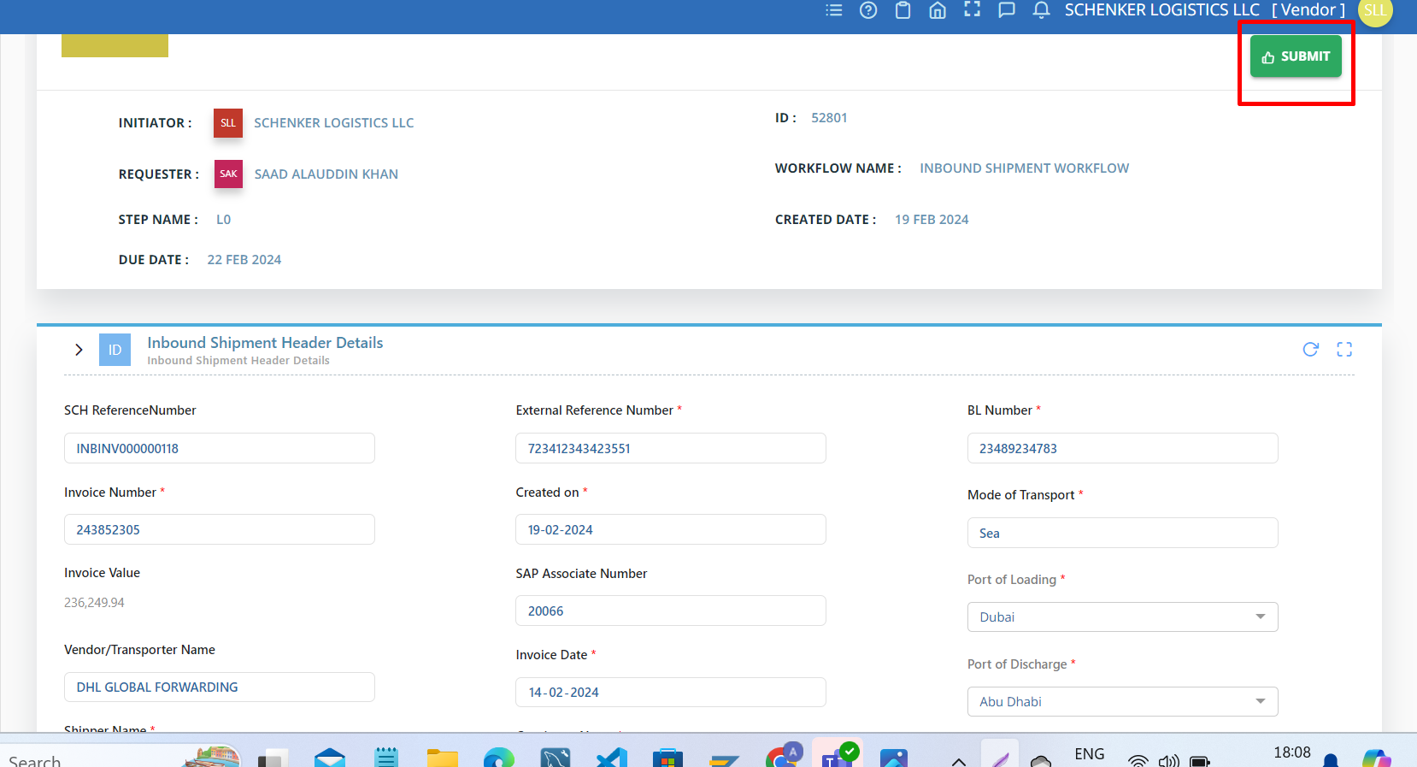

1. On that Submit popup, Next Approver and Remarks (Not mandatory) field will be shown. Then click on the “OK” button.

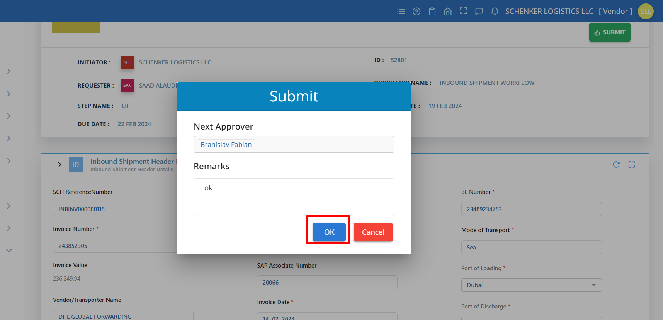

1. Again, the Shipping team will review and Update the Invoice and Submit.

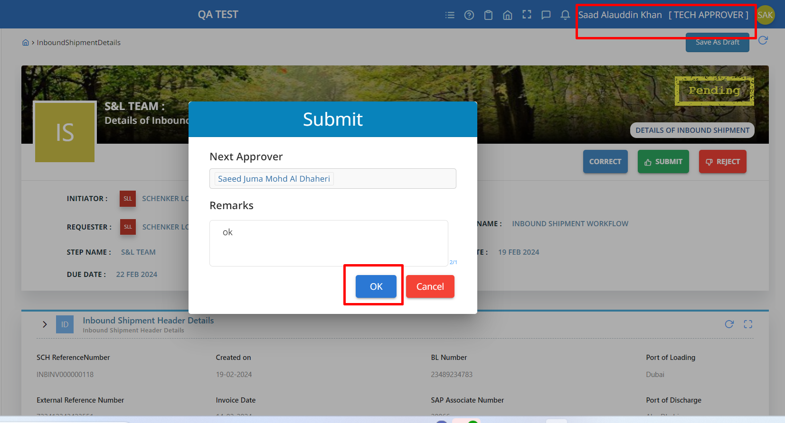

**Step 8:** A) After all the Approvers approve the Invoice, the status will be changed as “Approved” and the Invoice details will be moved to SAP. 

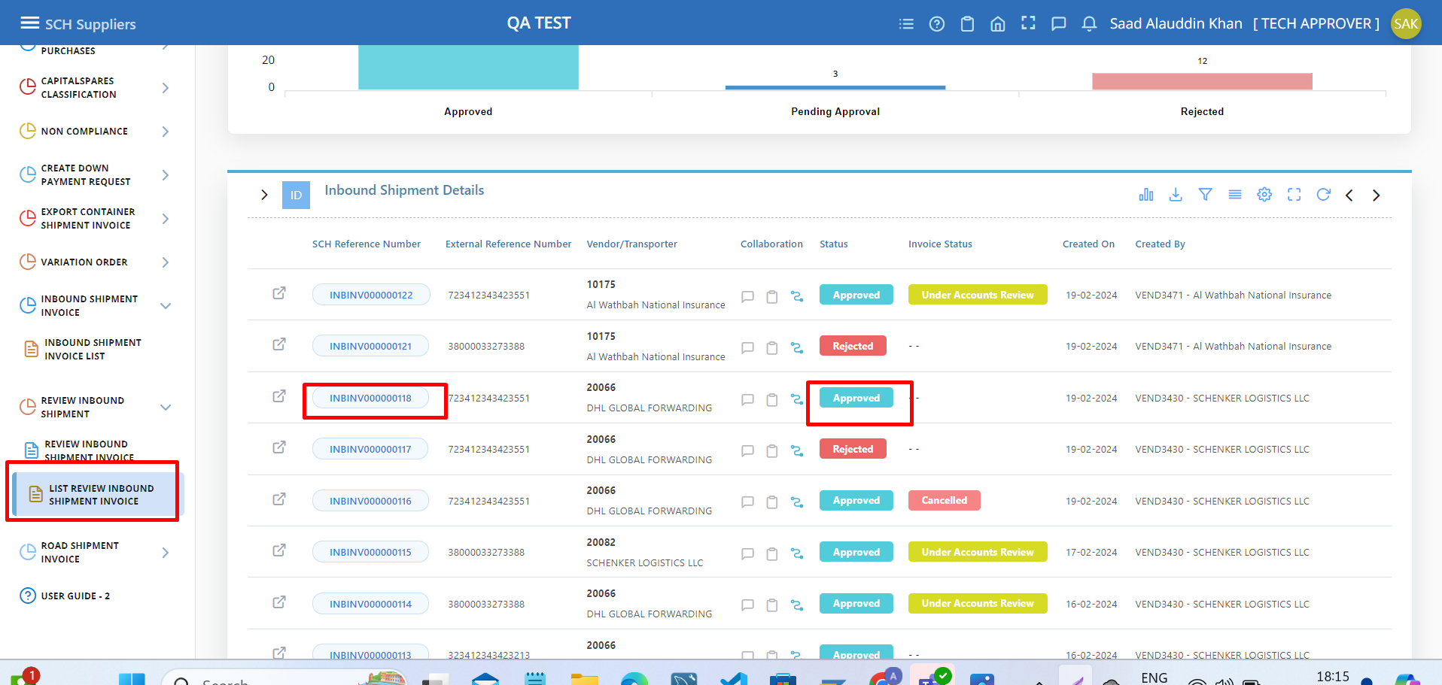

The Invoice details are posted in the SAP System and Processed with the SCH Reference Number.  
  
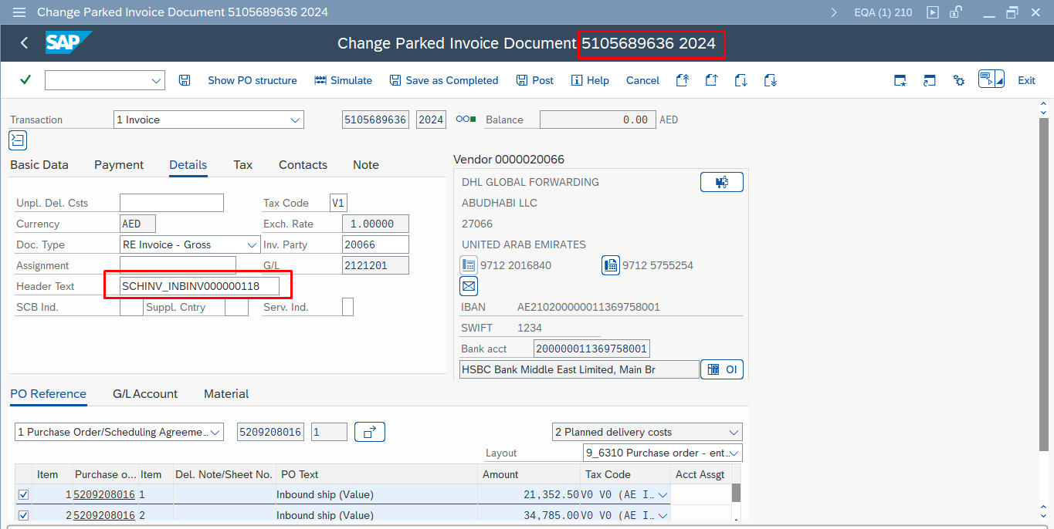

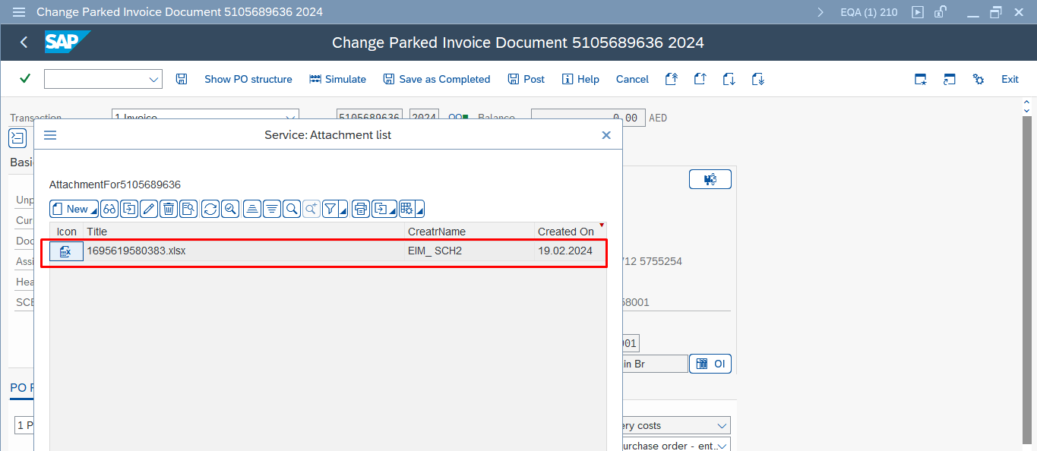

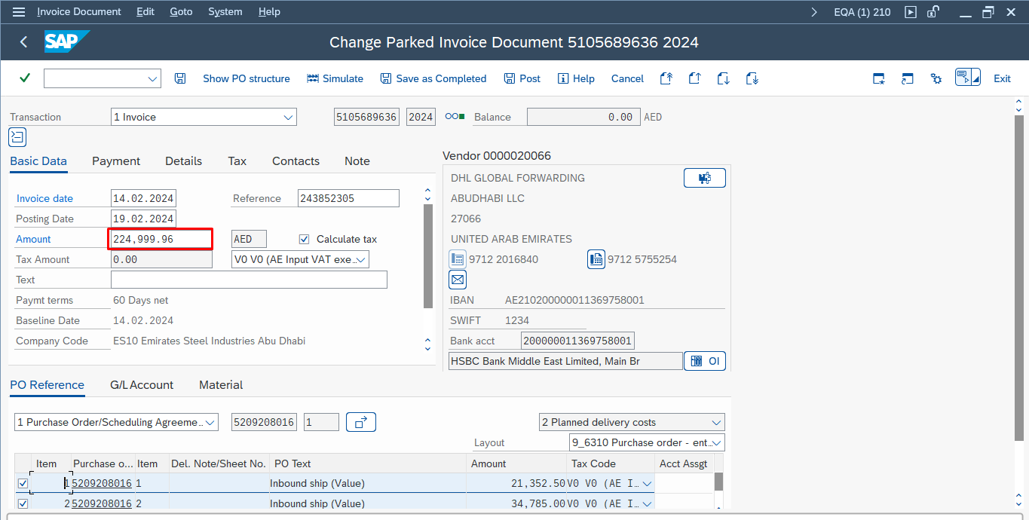

The Invoice Status will be shown as” Under Accounts Review” only when the” SCH Document Number” gets generated from the SAP side after the Invoice gets posted in SAP. In the List page you can the Invoice Status as Under Accounts Review, then If you click on the SCH Reference Number, it navigates to the details page. There we can see” Invoice Status” for that Invoice in the Inbound shipment Header Details section.  
  
  
  
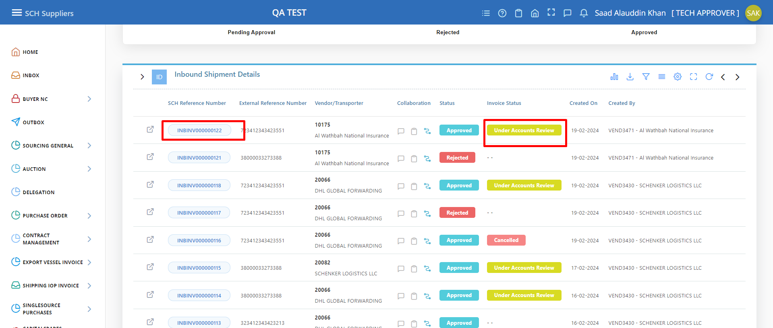

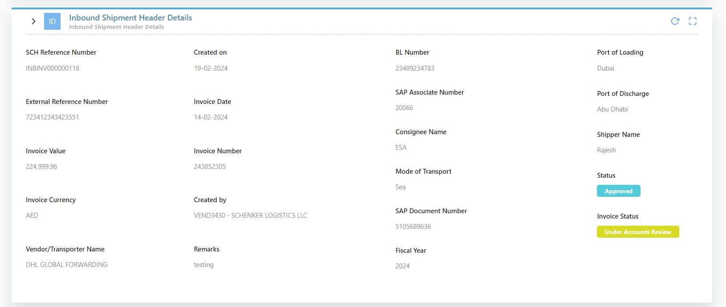

10) Summary of Test Results

|  |  |  |  |
| --- | --- | --- | --- |
| Test Passed / Failed: | Passed | | |
| Reasons (if failed): |  | | |
| Action to be taken |  | | |
| **Tested By** |  | **Acceptance by** |  |
| **Tested on:** |  | **Acceptance on:** |  |